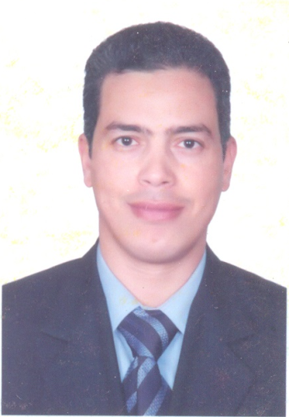

**Name: Magdi Mohammad Mostafa Hasan.**

**Work: Assiut University – Faculty of medicine – Department of Ophthalmology.**

**Birth date: 4/9/1975.**

**Current Job: Lecturer – Department of Ophthalmology.**

**Scientific history:**

* **M.B.B.ch of medicine and surgery, Sept. 1999 with (very good) degree from Assiut University.**
* **Master degree in Ophthalmology on 26/6/2004 with (good) degree from faculty of medicine – Assiut University.**
* **M.D. degree in Ophthalmology, Assiut University, 2017.**

**Job history:**

* **Internship at Faculty of medicine, Assiut University from 1/3/2000.**
* **Residency at Department of Ophthalmology, Assiut university hospital from 1/3/2001.**
* **Teaching assistant at Department of Ophthalmology, Assiut university hospital from 1/3/2003.**
* **Assistant lecturer at Department of Ophthalmology, Assiut university hospital from 8/5/2013.**
* **Lecturer at Department of Ophthalmology, Assiut university hospital from 2017.**

**Marital status: Married.**